**NOIDA PUBLIC SCHOOL**

**HALF YEARLY SYLLABUS (2024-25)**

**CLASS XII (HUMANITIES)**

**ENGLISH CORE**

**Reading:**

Unseen passage

**Creative Writing:**

Formal/Informal Invitations and Replies, Notice, Editorial Letter, Job Application, Article writing

**Literature: Flamingo:**

1.Lost Spring

2.Deep Water

3.The Rattrap

4.A Thing of Beauty( Poem)

5.Keeping Quiet (Poem)

**Vistas :**

1.Tiger King

2.Jouney to the end of the earth

**HINDI**

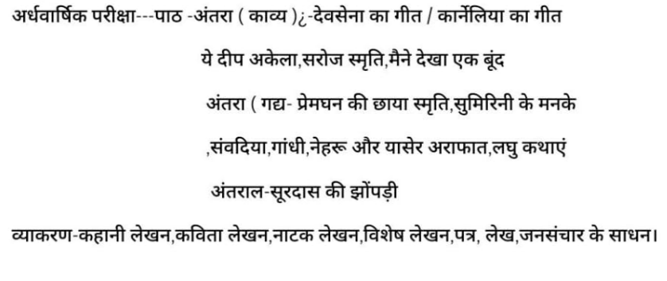

**HISTORY**

Chapter 1 Bricks , beads and bones

Chapter 2 Kings, farmer's and towns

Chapter 3 kinship,caste and class

Chapter 4 Thinkers , beliefs and buildings

Chapter 5 Through the eyes of travellers

Chapter 6 Bhakti-Shufi traditions

**GEOGRAPHY**

**BOOK 1 FUNDAMENTALS OF HUMAN GEOGRAPHY**

1 Human Geography

2 The World Population Density Distribution and Growth

3 Human Development

4 Primary Activities

5 Secondary Activities

6 Tertiary and Quaternary Activities

**BOOK 2 INDIAN PEOPLE AND ECONOMY**

Chapter 1 Population: Distribution, Density, Growth and Composition

Chapter 2 - Human Settlements

Chapter 3 - Land Resources and Agriculture

Chapter 4 - Water Resources

Chapter 5 - Mineral and energy resources

Chapter 6 - Planning and Sustainable Development in the Indian Context

**POLITICAL SCIENCE**

**Book 1- Politics in India since Independence**.

Ch 1- Challenges of Nation Building

Ch 2- The Era of One Party Dominance

Ch 3- Planned Development

Ch 4- India’s External Relations

Ch 5- Challenges & restoration of Congress System

**Book 2- Contemporary world Politics**

Ch 1- The End of Bipolarity

Ch 2- Contemporary Centres of Power

Ch 3- Contemporary South Asia

Ch 4- International Organization

Ch 5- Security in the Contemporary world

**ECONOMICS**

**Book 1-Macro Economics**

Ch-1 Introduction

Ch-2 Basic Concepts Of Macro Economics

Ch-3 National Income and Related aggregates

Ch -4 Methods of calculating national Income

Ch-5 Money

Ch – 6 Banking

Ch – 7 Aggregate Demand Aggregate Supply and Related Concepts

Ch-8 Short Run Equilibrium Output

Ch-9 Problem of deficient demand and Excess demand

Ch-10 Government Budget

Ch-11 Foreign Exchange Rate

Ch-12 Balance of Payment

**Book 2-Indian Economic Development**

Ch-1 Indian Economy on the eve of Independence

Ch-2 Economic system and common Goals of five year plans

Ch-3 Indian Economy ( 1950-1990)

**PHYSICAL EDUCATION**

Ch- 1 Management of Sporting events

Ch-2 Children and women in Sports

Ch - 3 Yoga as preventive measures for life style desease

Ch-4 Physical education for CWSN

Ch- 5 Sports and Nutrition

Ch- 6 Test and measurement in Sports